ASE LAB 9
Perform Static Code Analysis of a Java Program Containing Duplicate Code Statements Using SonarQube to Identity Code of Duplication and Maintainability Issues.

Objective
To analyze a Java program using SonarQube and identify repeated or duplicate code using Copy-Paste Detection (CPD).
Step 1: Open Docker Desktop
Firstly, open Docker Desktop.
Run the SonarQube container using Command Prompt:
docker run -d --name sonarqube -e SONAR_ES_BOOTSTRAP_CHECKS_DISABLE=true -p 9000:9000 sonarqube:latest
Wait for the command to finish. Then check the running container:
docker ps
If the SonarQube container is shown in the output, the container is running successfully.
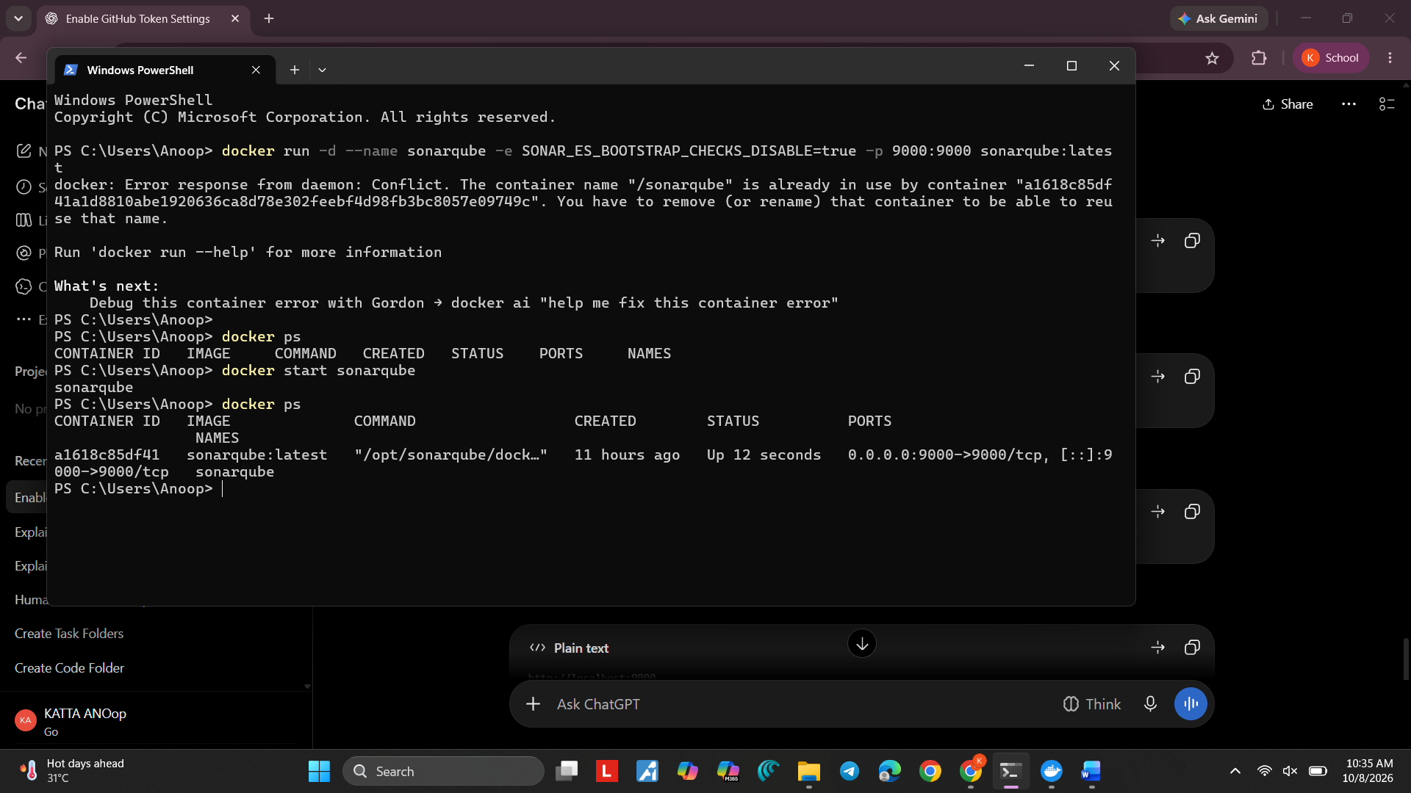
Step 2: Open SonarQube using localhost
Open a browser and enter:
http://localhost:9000
Login using:
Username: admin
Password: admin
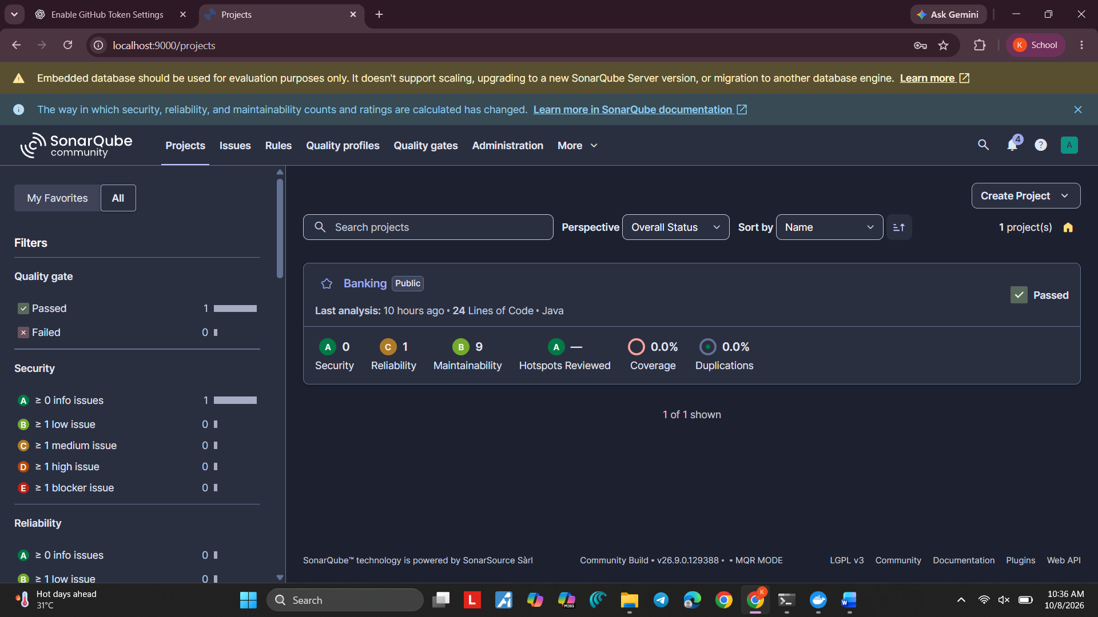
Step 3: Create the SonarQube Project
In SonarQube, create a new project.
Enter:
Project Name: DuplicateCode
Project Key: DuplicateCode
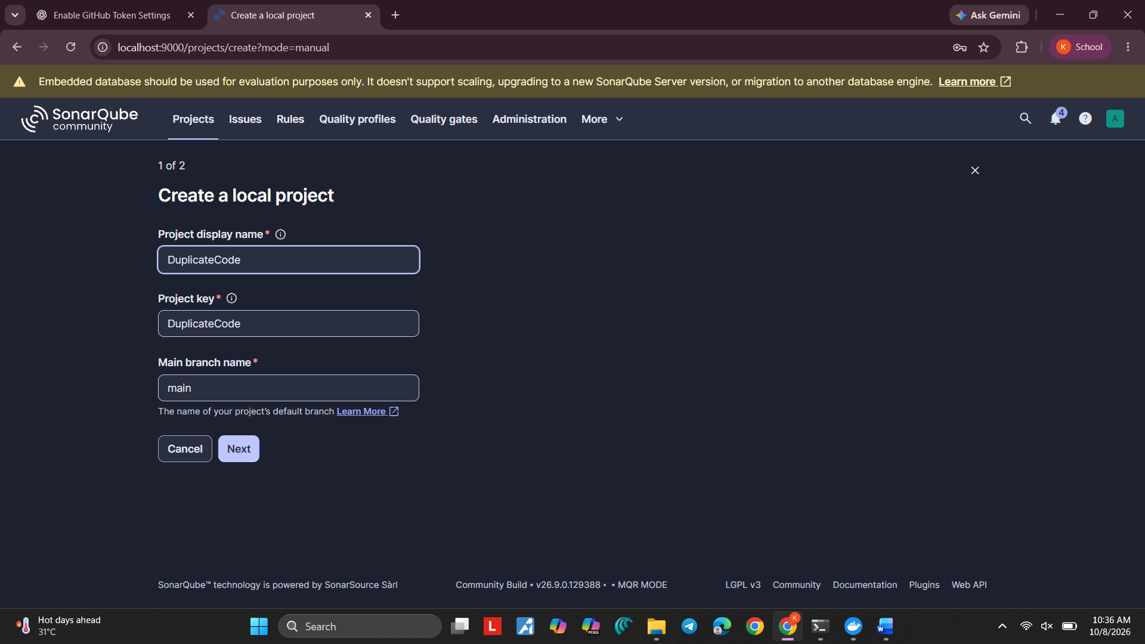
Keep the project public if that is the setting used in your class setup.
Step 4: Create the Java Project Folder
Create/open the Lab 9 folder:
D:\3-1\ASE\ASE LAB 9
The folder structure should be:
ASE LAB 9
│
├── sonar-project.properties
│
└── src
└── Main.java
Create/open sonar-project.properties and add:
sonar.projectKey=DuplicateCode
sonar.projectName=DuplicateCode
sonar.sources=src
sonar.host.url=http://localhost:9000
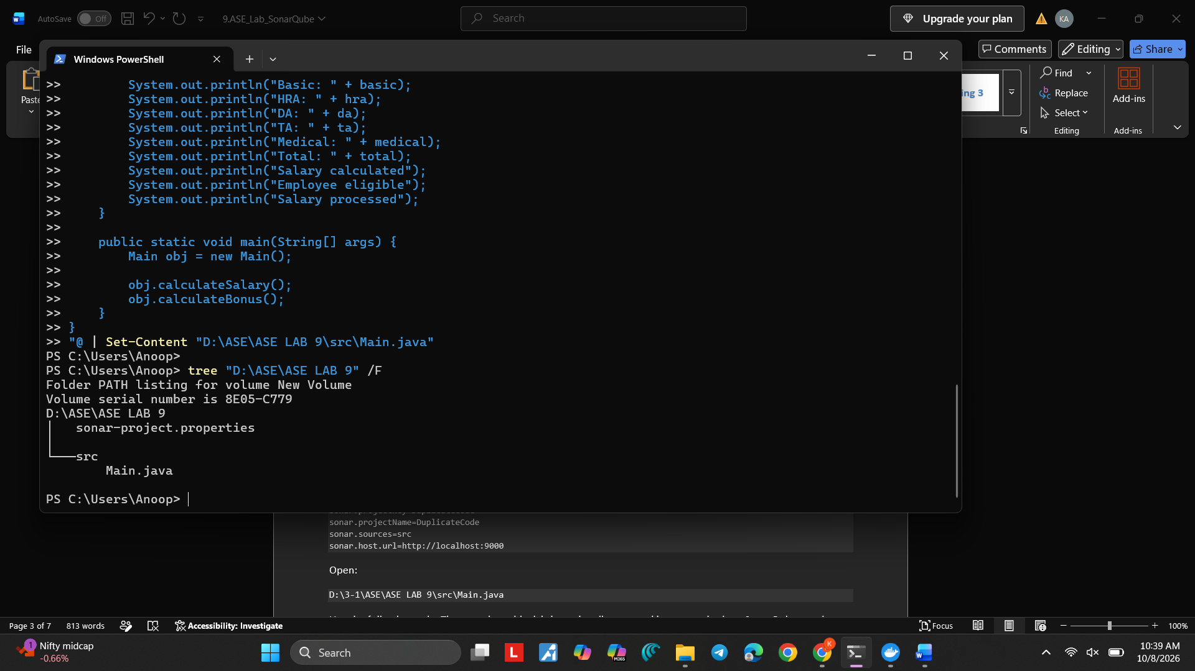Open:
D:\3-1\ASE\ASE LAB 9\src\Main.java
Use the following code. The same large block is intentionally repeated in two methods so SonarQube can detect duplicate code:
public class Main {
public void calculateSalary() {
int basic = 30000;
int hra = 5000;
int da = 3000;
int ta = 2000;
int medical = 1500;
int total = basic + hra + da + ta + medical;
System.out.println("Basic: " + basic);
System.out.println("HRA: " + hra);
System.out.println("DA: " + da);
System.out.println("TA: " + ta);
System.out.println("Medical: " + medical);
System.out.println("Total: " + total);
System.out.println("Salary calculated");
System.out.println("Employee eligible");
System.out.println("Salary processed");
}
public void calculateBonus() {
int basic = 30000;
int hra = 5000;
int da = 3000;
int ta = 2000;
int medical = 1500;
int total = basic + hra + da + ta + medical;
System.out.println("Basic: " + basic);
System.out.println("HRA: " + hra);
System.out.println("DA: " + da);
System.out.println("TA: " + ta);
System.out.println("Medical: " + medical);
System.out.println("Total: " + total);
System.out.println("Salary calculated");
System.out.println("Employee eligible");
System.out.println("Salary processed");
}
public static void main(String[] args) {
Main obj = new Main();
obj.calculateSalary();
obj.calculateBonus();
}
}
The code in calculateSalary() and calculateBonus() contains the same repeated block. This is the duplicate code that SonarQube will analyze.
Step 5: Install / Check SonarScanner
SonarScanner is used to send the Java project to SonarQube for analysis.
Check whether SonarScanner is installed:
sonar-scanner --version
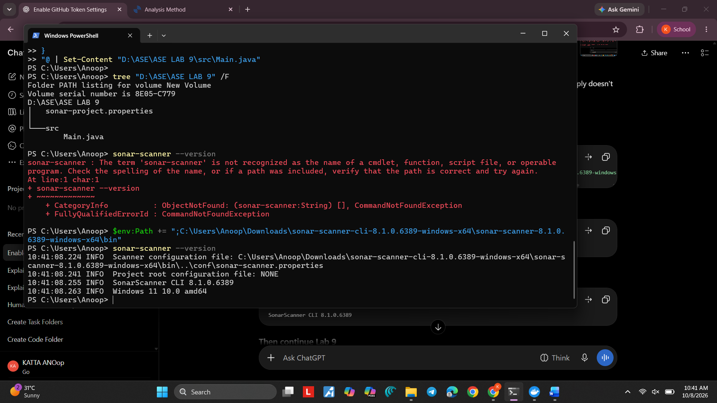You should see the SonarScanner version, for example:
SonarScanner CLI 8.1.0.6389
Step 6: Generate SonarQube Authentication Token
Go to SonarQube and login.
Then:
1. Open your profile from the top-right corner.
2. Open Security.
3. Enter a name for the token.
4. Select User Token if that option is shown.
5. Generate the token.
6. Copy the token and keep it safe. Do not share it.
Open Command Prompt and set the token for the current CMD window:
set SONAR_TOKEN=YOUR_TOKEN
Replace YOUR_TOKEN with the token you generated.
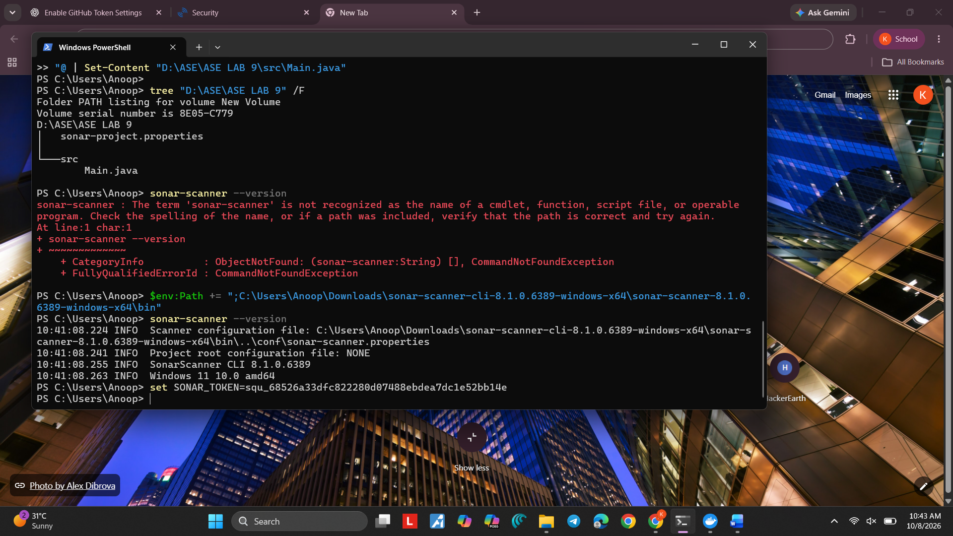
Step 7: Go to the Project Directory
Open Command Prompt and move to the Lab 9 project folder:
cd /d "D:\3-1\ASE\ASE LAB 9"
Check the files:
dir
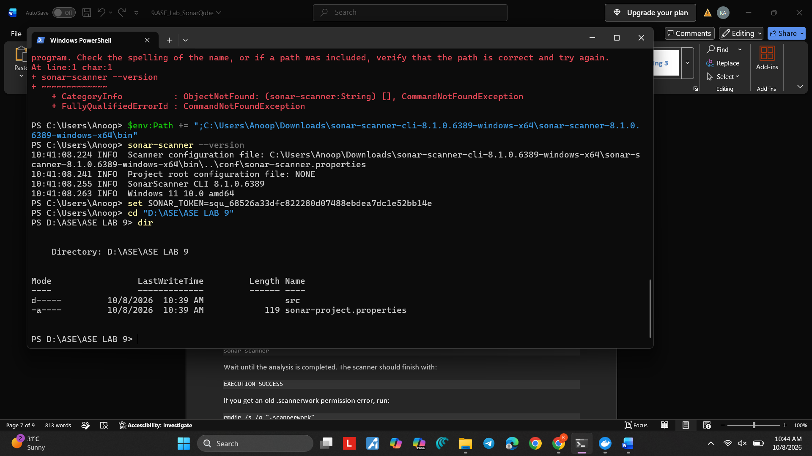You should see sonar-project.properties and the src folder.
Step 8: Run SonarScanner
Run:
sonar-scanner
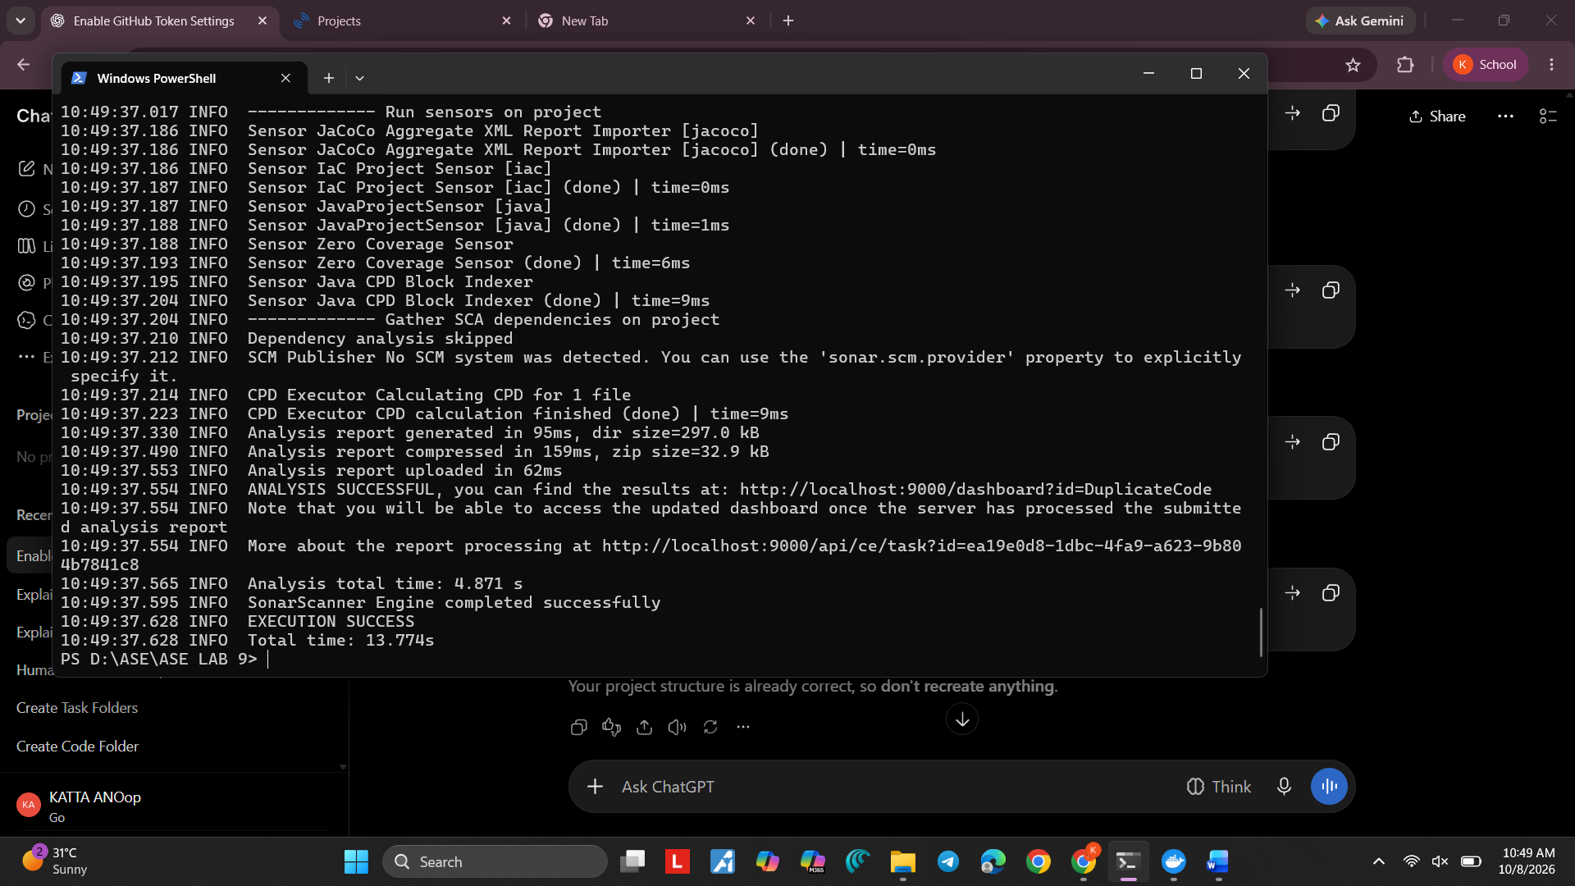Wait until the analysis is completed. The scanner should finish with:
EXECUTION SUCCESS
If you get an old .scannerwork permission error, run:
rmdir /s /q ".scannerwork"
Then run again:
sonar-scanner
If you get HTTP 401 Unauthorized, set SONAR_TOKEN again in the same CMD window and run sonar-scanner again.
Step 9: Open the SonarQube Project Dashboard
Open:
http://localhost:9000
Then go to:
Projects → DuplicateCode
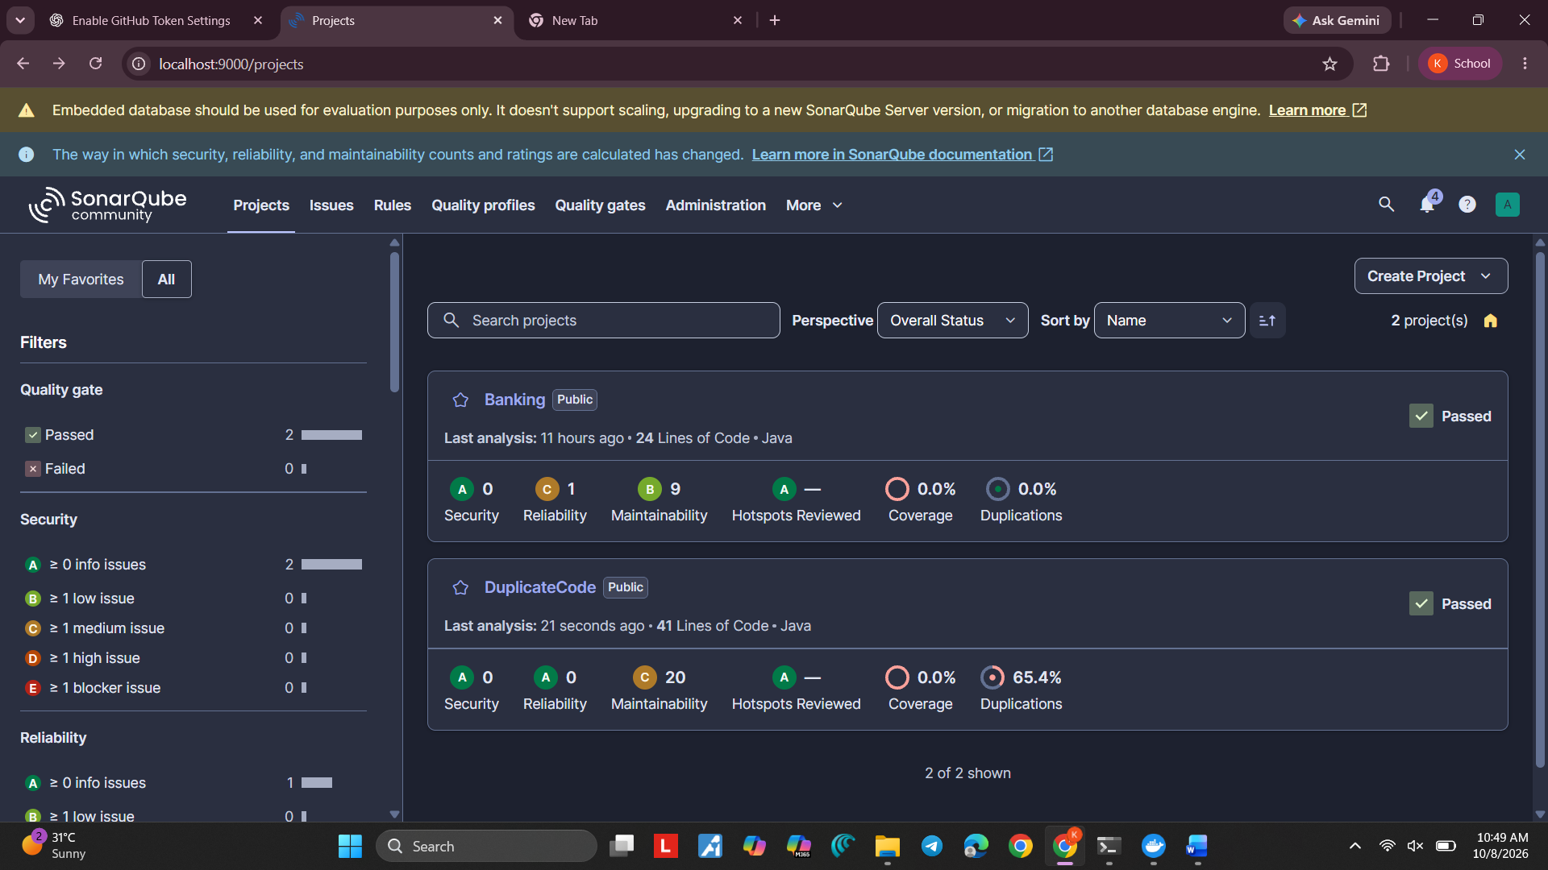
Open the project Overview.
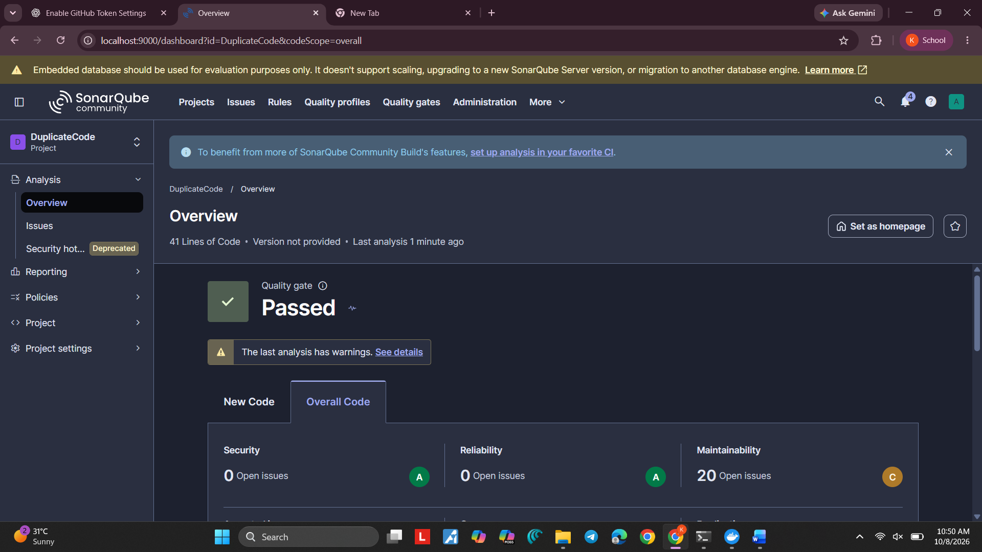
Step 10: Check Duplicate Code
In the dashboard, check the Duplications metric.
For this experiment, SonarQube should identify the repeated code and show a non-zero Duplications percentage.
The exact percentage depends on the code and SonarQube's CPD analysis. Record the percentage shown on your own dashboard.
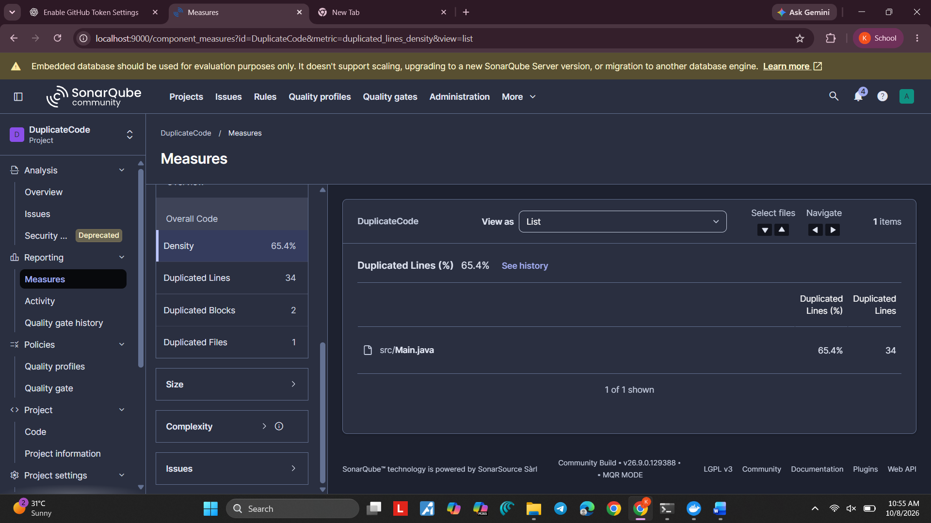
What is CPD?
CPD means Copy-Paste Detection. It is the SonarQube analysis used to find sufficiently large repeated code blocks. The Duplications metric shows the amount of duplicated code detected.
Observation
The Java program containing repeated code was analyzed using SonarQube. SonarQube's Copy-Paste Detection identified the repeated code, and the Duplications metric was displayed in the project dashboard.
Result
Thus, duplicate code was successfully analyzed and detected using SonarQube.
Screenshots to Take
- Docker Desktop / Command Prompt showing the SonarQube container running.
- SonarQube DuplicateCode project page.
- sonar-project.properties file.
- Main.java showing the repeated code.
- Command Prompt showing sonar-scanner and EXECUTION SUCCESS.
- Final DuplicateCode dashboard showing the Duplications percentage.
Important Notes
- Do not share your SonarQube authentication token.
- The exact Duplications percentage can be different for different code.
- A Quality Gate can be Failed because of other conditions such as coverage or issues; this is separate from whether duplicate code was detected.
- An SCM provider warning does not by itself mean duplicate-code analysis failed.

